**CHAPTER 2: POWER DISTRIBUTION SYSTEM**

**Introduction**

The power distribution system is used to define the flow of power within the entire electrical system. This system is used to transfer electric current from the transmission unit to the delivery unit. It consists of various electrical and electronic systems such as the battery, charging system, relay & fuse box and voltage monitoring system. The primary power transmission units are the battery and the alternator, R/R charging mechanism. The secondary power transmission units are the relay box and the voltage monitoring system. This power is later transmitted to various electric and electronic devices.

**Design Target**

There are primarily 4 design targets to be kept in mind while designing the power distribution system. These were decided on the onset of the project in reference to reviews from design judges at FSG.

1. **Designing a compact and robust relay box**

The current power distribution unit consisted of heavy weight relay and fuse holder unit. These covered at least 20 % of the firewall area. Thus a 50 % reduction in surface area of the relay box for required still keeping meeting the power demands.

1. **Use of appropriate cables to meet power consumption**

The use of well calculated power rating for each system would help in reduction wiring issue and reduce transmission loss along power cables.

1. **Maintain voltage stability and failure safety and detection**

Need of voltage stability is must in electrical and electronics devices. Use of protection circuits to provide for voltage and current instability as well as short circuits. Use of display technique to locate wiring faults.

1. **Use light weight batteries**

A stock bike battery weighs around 6 Kg which is very heavy for our car and hence the need arrived to use a lightweight battery.

**System Needs**

The PDS supplies power to various system in the vehicle. These consists of the ECU, the cooling system, the driver interface display system and data logging systems. This power is modulated through a relay box, a motor driver unit and a voltage monitoring systems.

The power distribution requirements are given below:

1. ECU MoTec M400 : 312 W
2. Cooling System : 80 W
3. Electronic Systems : 72 W

**Total Power Requirement = 464 W**

According to the above calculations a continuous 400 W power supply is a necessity which is sufficiently supplied by the alternator above 3500 RPM.

**ECU MoTec M400**

* The power is distributed among the fuel pump, ignition coils and injector values through a relay, an ignition module.
* The fuel pump consumes 10 amps @ 12 Volts to maintain fuel pressure at 50 psi.
* The injectors’ ohm values lie between 11.9 to 12.1 ohms. Considering 12 ohms average the average current consumed will be 1.1 amps.
* The ignition coils consumes 6 amps of current at every spark cycles.

**Cooling System**

* The cooling system consists of 2 motors; one used for the radiator fan and the second used as a water pump.
* The water pump motor speed is controlled through a motor driver circuit and later was controlled using solid state relays.
* The water pump motor is run for 25 LPM @ 3.7 amps.
* The radiator fan motor consumes 40 W of power.

**Electronic Systems**

* The electronics system consist of the driver interface display system, the centralized telemetry system and the data logging system.
* The DI system and the logging system consumes 48 W of power continuously
* The centralized telemetry system consumes a max of 2 amps of current.

**System Design**

**Battery**

The battery used in most cars is lead acid batteries but these prove to be too heavy for a formula student race car. Batteries need to be lighter for better weight reduction and still provide the needed performance. The batteries need to be rechargeable through a rectifier connected to the alternator of the engine. Hence to justify our battery selection various decision and analysis were made.

**Battery Selection Criteria**

* Battery Weight : **Lesser the better**
* Battery Capacity (mAH) : **More the better**
* Battery Discharge rate (Amp) : **More the Better**
* Battery Cost : **Less the better**
* Battery Size (Volume) : **Less the better**

We made a decision matrix as shown below to give weightages to the parameters which were more important than the other.

**Decision Matrix**

|  |  |  |  |  |  |  |  |  |  |  |  |  |
| --- | --- | --- | --- | --- | --- | --- | --- | --- | --- | --- | --- | --- |
|  | | weight | | Capacity | | discharge | | cost | | size |  | |
| Weight | | 1 | | 1 | | 1 | | 1 | | 0 |  | |
| Capacity | | 1 | | 1 | | 1 | | 1 | | 0 |  | |
| Discharge | | 1 | | 1 | | 1 | | 0 | | 0 |  | |
| Cost | | 1 | | 1 | | 0 | | 1 | | 0 |  | |
| Size | | 0 | | 0 | | 0 | | 0 | | 1 |  | |
| Total | | 4 | | 4 | | 3 | | 3 | | 1 |  | |
| weightage | | 26.667 | | 26.6667 | | 20 | | 20 | | 6.67 |  | |
|  | |  | |  | |  | |  | |  |  | |
|  | |  | |  | |  | |  | |  |  | |
| Chemistry | | weight | | Capacity | | discharge | | cost | | size |  | |
| Lead Acid | | 0 | | 1 | | 0 | | 1 | | 0 |  | |
| Advanced | | 1 | | 0 | | 1 | | 0 | | 1 |  | |
|  |  | |  | |  | |  | |  | | |
| Weighted | | weight | | Capacity | | Discharge | | Cost | | Size | Total Score | |
| Lead acid | | 0 | | 26.6667 | | 0 | | 20 | | 0 | 46.7 | |
| Advanced | | 26.667 | | 0 | | 20 | | 0 | | 6.67 | 53.3 | |

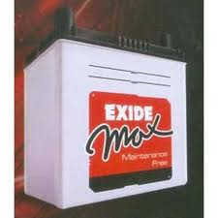 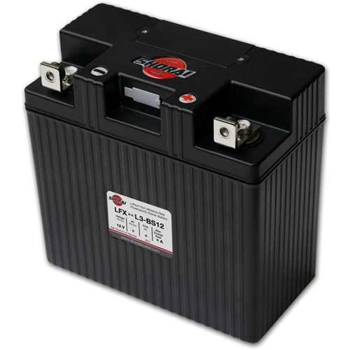

**Fig 2.1.a Fig 2.1.b**

**Engine Starter Batteries Car Main Battery**

Here in table number one we gave weightages to the parameters. The weightage points have been normalizes to a total of 100 points.

In table 2 a comparison of Lead Acid Battery with the existing braille battery which was used in FSG 2012. We have represented advanced chemistry batteries with the braille battery. Advanced chemistry batteries include LeFePO4 batteries and Li Ion batteries. Batteries of these chemistries were found suitable by us for automotive use.

Adding up the scores from table one and two, we can see that the weightage total of the scores for advanced chemistry is higher than lead acid battery by 6.6 points. Thus we justified the use of Advanced Chemistry batteries.

Next we searched of various LiFePO4 chemistry batteries. A123 systems Inc. produces industrial grade LiFePO4 batteries which conform to the rule. They have two subtypes of batteries. One type having capacity of 2.3mAH costing $8 per battery and other having capacity of 15AH and costing $28 per battery. Later a shift was made to a much lighter and higher amp hour battery; Shorai batteries 13.2 Volts @ 14Ah weighing only 670 grams.

The other batteries which we searched for was braille.

|  |  |  |  |  |  |  |
| --- | --- | --- | --- | --- | --- | --- |
| battery chemistries | weight | Capacity | discharge | cost | size |  |
| LiFePO4 (A123/Shorai) | 1 | 0 | 1 | 1 | 1 |  |
| Li Ion (Braille) | 0 | 1 | 0 | 0 | 0 |  |
|  |  |  |  |  |  |  |
|  |  |  |  |  |  |  |
| Weighted | Weight | Capacity | Discharge | Cost | Size | Weighted Score |
| LiFePO4 (A123)/Shorai | 26.66667 | 0 | 20 | 20 | 6.67 | 73.33333 |
| Li Ion (Braille) | 0 | 26.6667 | 0 | 0 | 0 | 26.66667 |

Based on the selection parameters, we found the A123 batteries to be suitable for use. The above decision table is weighted towards A123 batteries by a margin of 46.6 points.

A123 systems have many available battery capacities having varied costs. We found two types of batteries suitable for our use. One was a low capacity battery: A123 ANR26650M1A 2.3AH cells and a high capacity battery: A123 40155 15AH cells.

|  |  |  |
| --- | --- | --- |
| Parameter | A123 40155 | A123 ANR26650M1A |
| Capacity | 15AH | 2.3AH |
| Weight | 420gms | 73gms |
| Continuous Discharge | 10C=150Amps | 30C=69Amps |
| Size | 40mm dia * 155mm length | 26mm dia *65mm length |
| Cost per cell | $28 | $8 |

We analyzed these parameters and also constructed a decision matrix to help us decide a correct battery. Weight was a major criterion which we wanted to reduce. Thus without the decision matrix too we selected the 2.3AH ANR26650M1A battery simply as it was cheaper, lighter and smaller in volume.

|  |  |  |  |  |  |  |
| --- | --- | --- | --- | --- | --- | --- |
| A123 type | weight | capacity | discharge | cost | size |  |
| Small | 1 | 0 | 0 | 1 | 1 |  |
| Large | 0 | 1 | 1 | 0 | 0 |  |
|  |  |  |  |  |  |  |
| Weighted |  |  |  |  |  |  |
| Small | 26.66667 | 0 | 0 | 20 | 6.67 | 53.33333 |
| Large | 0 | 26.6667 | 20 | 0 | 0 | 46.66667 |

Thus going according to the matrix above, the ‘small’ A123 ANR26650M1A battery is best for our application.

**Battery Pack Design:**

**Detailed Battery Specifications**

With patented Nano-Phosphate technology, A123-26650 cells boast many advantages over Li-Poly,:  
Safety, Faster Charge Rate, Cycle Life, Extended Shelf Life, Durable metal case and Lower cost

Nominal Voltage: 3.3V  
Nominal Capacity 2300mAh  
Recommended Charge : 3A to 3.6V CCCV (constant current - constant voltage)  
Recommended Fast Charge: 10A to 3.6V CCCV  
Fast charge time: 15 minutes  
Continuous Discharge: 30C  
Pulse: 60C  
Dimensions 26mm(1.04") dia. x 65mm(2.5") ht  
Weight: 72 grams  
Cycle Life at 10C discharge: 1000+  
Applications: power tools, RC  racing car, high power EV,etc  
Power: Over 3000 W/kg and 5800 W/L  
Safety: Excellent abuse tolerance and environmentally friendly  
Life: Excellent calendar life, 10X cycle life vs. conventional lithium ion

A123 batteries use a new type of cell construction based on a dual plate tubular design optimized to deliver very high power with high efficiency. This new design does not use crimp seals and instead opts for a more advanced all laser welded construction optimized for very low humidity penetration over the life of the battery as well as stronger, thicker dual plate headers.

Battery Pack Design: Upon studying the specifications we concluded that the battery pack should be 4S4P.

Each battery has nominal voltage of 3.3v. Thus four batteries in series give us 13.2v. 4 such packs of 4 batteries were connected in series to boost the current capacity to 9.2AH.

The batteries terminals were connected with pure nickel solder tabs. These tabs were welded to the battery terminals using spot welding.

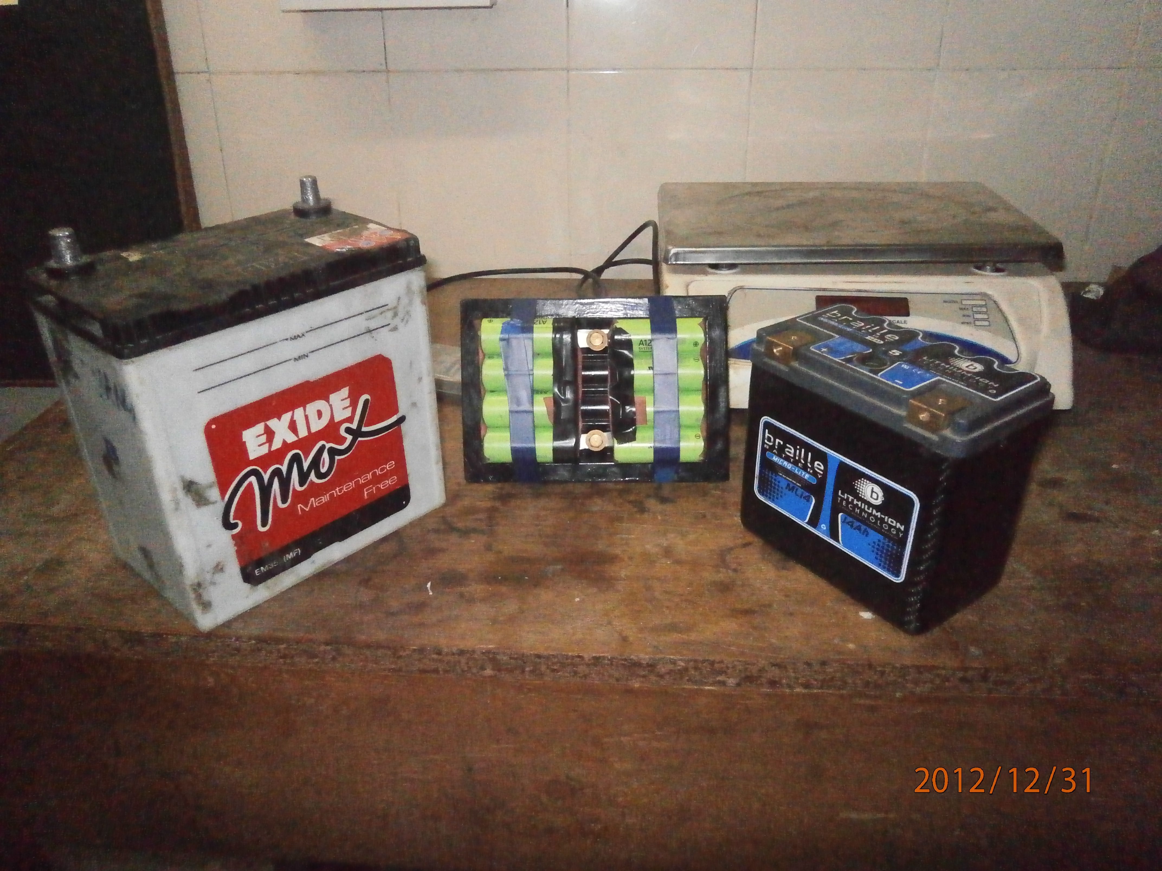

**Fig 2.2**

**Exide,A123,Braille**

**A123 Battery Testing**

While the battery was being tested Shorai batteries came into picture which weighed 670 grams with 13.2 Volts @ 14 Ah. Another criteria looked into was the battery power usage and charging specifications over an endurance run. Since a lower amperage battery takes less time to charge (RC time constant) but the total power delivered deteriorate by the battery over long period of time. The calculations were done below:

**Engine out at various RPMs**

|  |  |  |  |  |  |  |
| --- | --- | --- | --- | --- | --- | --- |
| Rev | Power of one phase |  | Voltage | Current |  | Total Power |
|  |  |  |  |  |  |  |
| 2500 U/min | 85 W |  | 31,5 V | 5,4 A |  | 170,1 W |
| 3000 U/min | 117 W |  | 37,2 V | 6,5 A |  | 241,8 W |
| 3500 U/min | 150 W |  | 43 V | 7,2 A |  | 309,6 W |
| 4000 U/min | 180 W |  | 47,2 V | 8,2 A |  | 387,04 W |
| 4500 U/min | 220 W |  | 52 V | 9,25 A |  | 481 W |
| 5000 U/min | 244 W |  | 55 V | 9,7 A |  | 533,5 W |
| 5500 U/min | 287 W |  | 59,6 V | 10,5 A |  | 625,8 W |
| 6000 U/min | 314 W |  | 62,4 V | 11 A |  | 686,4 W |
| 6500 U/min | 355 W |  | 65,6 V | 11,7 A |  | 767,52 W |
| 7000 U/min | 390 W |  | 69 V | 12,3 A |  | 848,7 W |
| 7500 U/min | 426 W |  | 71,5 V | 12,8 A |  | 915,2 W |
| 8000 U/min | 460 W |  | 74,3 V | 13,2 A |  | 980,76 W |
|  |  |  |  |  |  |  |

According to the above table it is clear that to sustain the engine and the electronics system the engine needs to be at least 4000 RPM.

An endurance takes around 30 min. Hence an A123 battery pack is able to supply power of 244 W of power as compared to a Shorai battery which provides with 370 W. According to the table and the RPM histogram shows the range near 4500 to 7000 RPM. This shows that a 14 Ah battery is much more reliable as compared to a 9.2 Ah battery system.

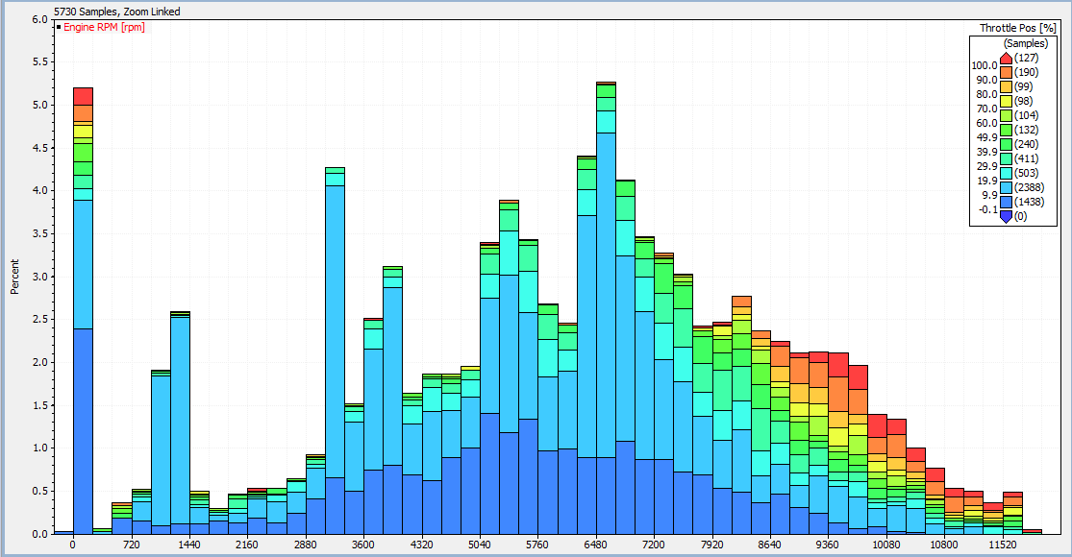

**Fig 2.3**

**RPM Histogram of Endurance Run**

The entire battery pack along with its casing weighed 1850 grams which was quite heavy as compared to the Shorai batteries which weigh 670 grams is also a criteria taken into picture during selection of Shorai Power Battery Systems over A123 Systems.

**Shorai LiFePO4 Battery System**

The Shorai Battery System is a 13.2 Volt battery @ 14Ah rating. These batteries were acquired from Shorai Power Battery Systems. In accordance to the power consumption the 14 Ah battery system was a verified battery pack system. The entire battery weighs 670 grams

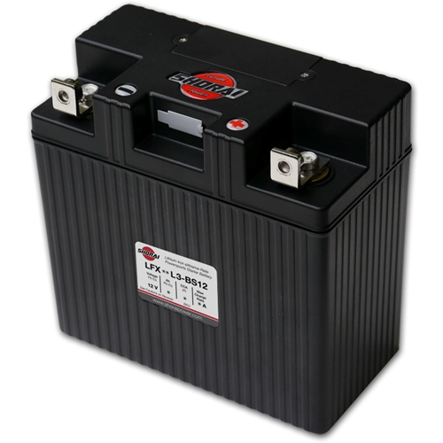

**Fig 2.4**

**Shorai Battery Pack**

Advantages of using the selected battery:

* Ultra-light. One Fifth the weight of convectional batteries on average (670 grams)
* Zero sulfation, for longer service life
* More current for burst: (210 Amps)
* Military spec Carbon Composite Case
* Fast charging: 15 mins
* No explosive gasses during charge
* No need of using a BMS

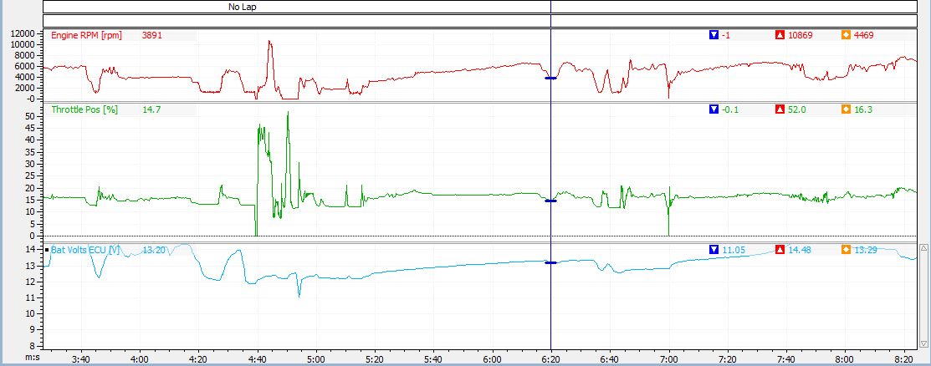

**Fig 2.5**

**Testing Log**

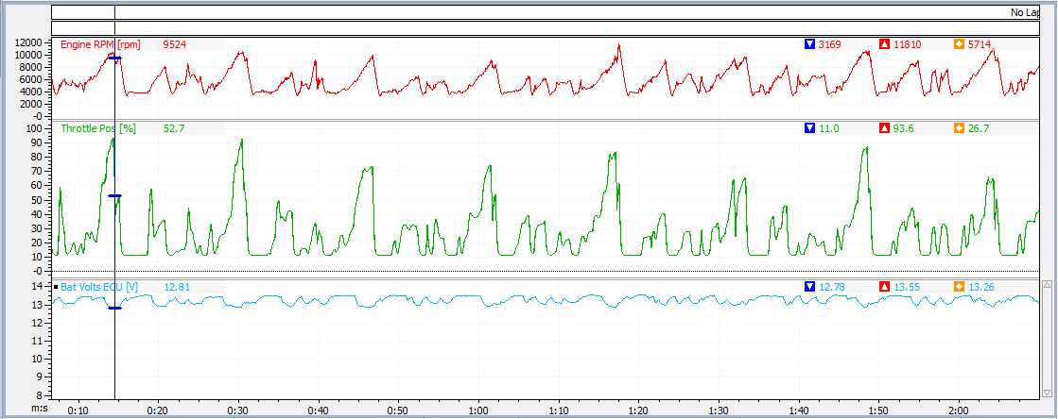

**Fig 2.6**

**Testing Log**

From the above log we know that the average battery voltage is at 13 Volts and the charging rate response of the battery is very good and this was achieved by a lower RC constant of the charging system which was possible due to a very compact design of the battery system.

**Relay Box**

The Relays used at FSG 2012 were standard 12v 30A/40A automotive relays. These relays were used with standard relay holders. The combined weight of a relay along with the holder was 54 grams. Our team goal was to try and reduce the weight and size of the relays and the accompanied wiring. The total weight of the all the relays and their holders was 54 grams.

Thus for FSG 2013 we searched for new relays which were lighter and took less volume. We found PCB mountable relays rated to 30A which were appropriate for our use. They were also cheaper as compared to the automotive relays.

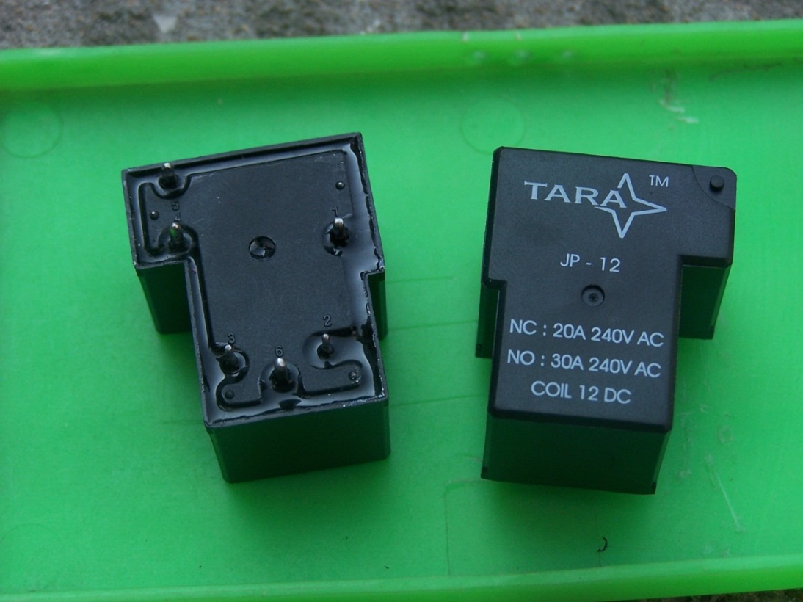

**Fig 2.7**

**Relays**

We made a decision matrix analysis to support our choice of PCB mountable relays over automotive relays.

|  |  |  |  |  |  |  |  |  |
| --- | --- | --- | --- | --- | --- | --- | --- | --- |
|  | | |  | |  | |  |  |
| Selection Criteria | | | Size | | Weight | | Cost |  |
| Size | | | 1 | | 1 | | 0 |  |
| Weight | | | 1 | | 1 | | 0 |  |
| Cost | | | 0 | | 0 | | 1 |  |
| Total | | | 2 | | 2 | | 1 |  |
| Weighted Total | | | 40 | | 40 | | 20 |  |
|  |  |  | |  | |
| Relay Type | | | Size | | Weight | | Cost |  |
| Automotive Relays | | | 0 | | 0 | | 1 |  |
| PCB Mountable Relays | | | 1 | | 1 | | 0 |  |
|  | | |  | |  | |  |  |
| Relay Type | | | Size | | Weight | | Cost | Total Score |
| Automotive Relays | | | 0 | | 0 | | 20 | 20 |
| PCB Mountable Relays | | | 40 | | 40 | | 0 | 80 |

Thus from the cost tables we can see that PCB mountable relays have a huge advantage over automotive relays.

For mounting the relays we designed a PCB using Eagle Cadsoft© PCB design software. We tried to make the design as compact as possible. On the PCB board we have provided one terminal for supply from the battery which supplies power to all the relays for purpose of actuation continuously. A relay is actuated by grounding the actuating terminal of the relay. We have thus provided terminal blocks where there ground actuating signals can be given.

On the other end of the board we have provided outputs of the relays a pads on the PCB where we can attach ring crimped wires using an M4 bolt with a nut. The widths of the tracks of the PCB have been adjusted to specific current requirement of the various components being controlled by the relays.

The Relay Board has 5 relays. They control the fuel pump, Motec ECU, cooling pump, ignition.

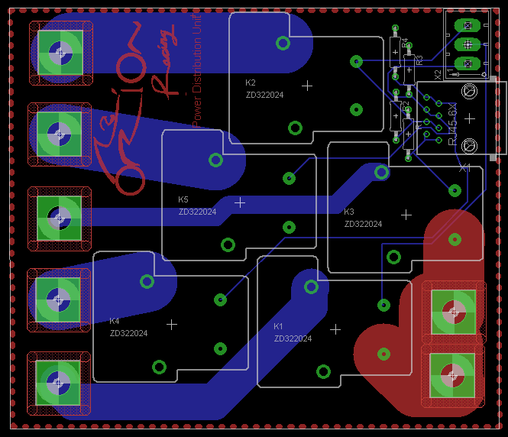

**Fig 2.8**

**Relay Board**

For the starter motor relay due to the high current requirement, we have used a standard starter motor relay. It is Ground actuated by the starter button.

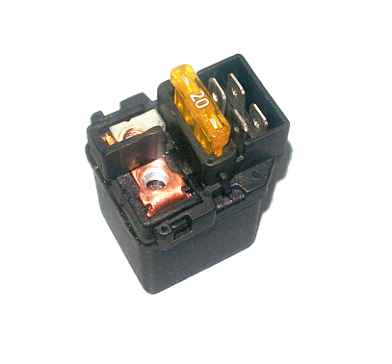

**Fig 2.9**

**Starter Relay**

The entire relay board has been placed of a plate made of Fibre Glass. We used Fibre glass since it is light and strong and unlike Carbon Fibre, it does not conduct electricity. The relay board is covered by the box which was made using 3D printing technology. The material used for 3D printing is plastic. The box has provisions for slots which can separate the various wires going out of the relay board. The relay board with all the relays and fasteners attached weighs 152 grams. This is a reduction of 300 grams over the previous setup of 2012.

**Voltage Monitoring System**

The issue we faced last year was the voltage regulation unit was a simple series voltage regulator giving 8 volts and 5 volts without any protection units. This would lead to system failure if a short circuit occurred somewhere in the wiring harness. Last year the ignition modules and the injector coils blew up due to inverse voltage application. To prevent this from happening, a voltage regulation system was made along with short circuit protection, inverse voltage protection and over current protection.

A transistor circuit was designed to prevent short circuit within the entire system. An n- channel MosFet is used to prevent inverse voltage problems and a current limiting diode was used for current limitation. Short circuit protection is achieved using two transistors; npn and pnp with pass of the current through them if there is any short within the system. The VRS also act as an routing path for sensors which are then given to the steering wheel system.

**Short Ciruit Protection Simulation**

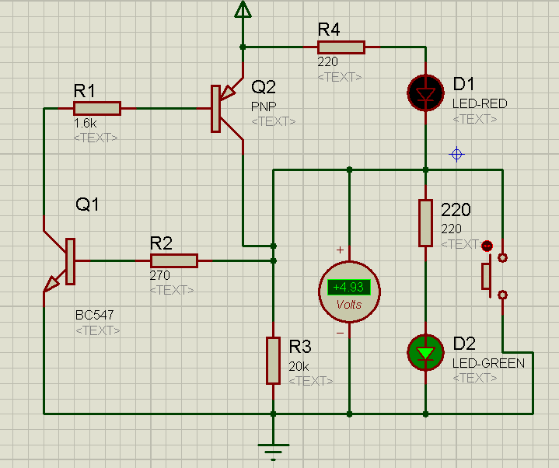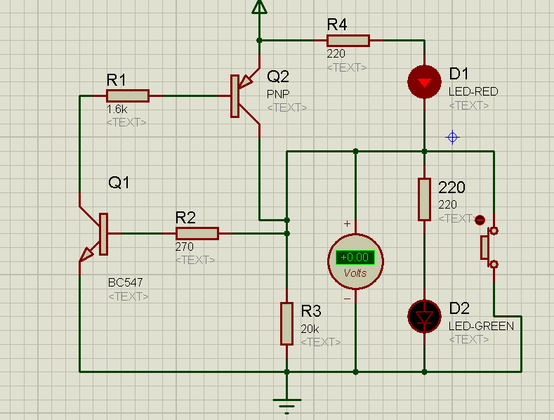

**Fig 2.10**  **Fig 2.11** **Short Circuit Protection On**  **Short Ciruit Proctection Monitoring**

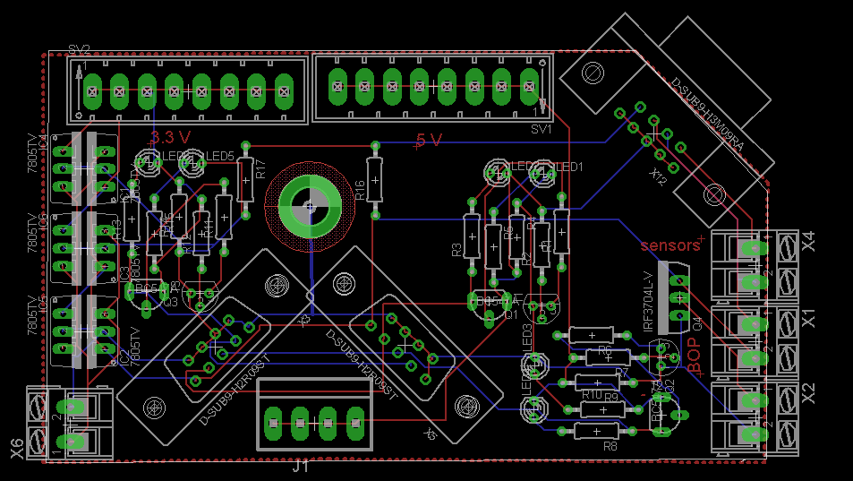

**Fig 2.12**

**Voltage Regulation System**

A voltage regulator is designed to automatically maintain a constant voltage level. A voltage regulator may be a simple "feed-forward" design or may include [negative feedback](http://en.wikipedia.org/wiki/Negative_feedback) [control loops](http://en.wikipedia.org/wiki/Control_theory). It may use an electromechanical [mechanism](http://en.wikipedia.org/wiki/Mechanism_(technology)), or electronic components. Depending on the design, it may be used to regulate one or more [AC](http://en.wikipedia.org/wiki/Alternating_current) or [DC](http://en.wikipedia.org/wiki/Direct_current) voltages.

Electronic voltage regulators are found in devices such as computer [power supplies](http://en.wikipedia.org/wiki/Power_supply) where they stabilize the DC voltages used by the processor and other elements. In automobile [alternators](http://en.wikipedia.org/wiki/Alternator) and central [power station](http://en.wikipedia.org/wiki/Power_station) generator plants, voltage regulators control the output of the plant. In an [electric power distribution](http://en.wikipedia.org/wiki/Electric_power_distribution) system, voltage regulators may be installed at a substation or along distribution lines so that all customers receive steady voltage independent of how much power is drawn from the line.